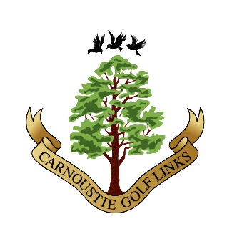
Carnoustie Golf Links Management Committee Limited (CGLMC Ltd)
Scottish Charity No. SCO45236

Community Benefits Programme
Supporting Community Development in Angus

The CGLMC Community Benefits Programme is aimed at:

- supporting children, learning and youth development
- promoting and supporting golf participation
- supporting environmental protection and improvement
- promoting participation in sport and recreational activities
- supporting arts, culture and heritage
- supporting community health and wellbeing
CGLMC Ltd will consider applications for financial support from any individuals or organisations who meet that criteria and whose activities take place within the Carnoustie and District Electoral Ward.

Please note –
We are unlikely to provide financial support to fund the following:

- applications from organisations whose activities are conducted out-with the Carnoustie and District Electoral Ward boundary.
- wages and salaries.
- events that are aimed at raising money on behalf of another charity (we would consider donating directly to the benefitting charity, provided it meets our objectives).

Summer 2022 funding round
Applications must be submitted on the Community Benefits Application Form by Monday 15 August 2022. Applicants will be notified of the outcome after 19 September 2022 and successful applicants will be invited to attend a presentation at Links House in October 2022 to receive their awards.

Please note - applications for funding to support 2022 Christmas events should also be submitted in the 2022 Summer funding round, by 15 August 2022.

Carnoustie Golf Links Management Committee
Community Benefits Grant
Application Form

Applicant’s/Organisation’s Name

1 – Organisation name
Aims/Purpose of the Organisation

Name:

Address:

Tel: Mob:

Email:

Contact Details

Is the applicant a charity or Community Amateur Sports Club?

YES/NO

If yes, please provide the Charity Registration Number:

£
Purpose of Funding
Application Amount
Details of Expenditure
Cost breakdown. £ inc. VAT
1.
2.
3.
4.
5.
6.

Total £

TOTAL

Amount requested from CGLMC Ltd £

Have you raised any funds for this project already or do you plan to raise funds from other sources?
Please specify below:
Value £
e.g. £5000
1.
2.
3.
4.
TOTAL

Source of Income Progress of your application
Lottery Funding Approved & payment pending.

The following information is required for applications greater than £2500 only.

If your current cash and bank balances exceed the amount requested, please advise why additional funds are required.

Please supply a copy of your latest bank statement (for all bank accounts held) with this application and if available please enclose a copy of your latest annual accounts.

TERMS & CONDITIONS OF FUNDING:

- If your application is successful and once funding has been made, you may be required to provide evidence of expenditure (in the form of receipts). You may also be required to provide a report and photographic evidence of your completed project.
- If you are unable to complete the funded project CGLMC Ltd may require some or all of the funding to be refunded.
- The support/assistance of CGLMC LTD is to be mentioned in all publicity.

I understand and accept the Terms & Conditions of funding.

............................................................
Applicant/Project Co-ordinator

..................................
Date

Send your completed application to:
Donald Archibald
Community Benefits Liaison
CGLMC Ltd
Links House
Links Parade
Carnoustie
Angus
DD7 7JF

or email your application to:
community@carnoustiegolflinks.co.uk

